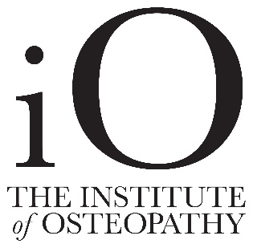
Explicit Consent
I explicitly consent to you creating and storing medical records concerning my treatment, which may include details concerning my medication, treatment and other issues affecting my health conditions, in accordance with the General Data Protection Regulation (GDPR). I understand that these records will be retained for eight years, (or until I reach 25 in the case of someone aged 16 - 18), when treatment is ceased in order to comply with the Institute of Osteopathy legal guidelines. I understand that these records will be processed in accordance with your 2018 Privacy Notice, a copy of which I have seen.

I have read and understood the above information and give my explicit consent:

Signed …………………………………………….. Date: ………………………………

Patient name: ………………………………………………………………………………………………

If acting in the capacity of a legal guardian, please state your role and authority

……………………………………………………………………………………………………………………..

For future appointments and administration, our preferred communication route/s is:

[ ] Telephone
[ ] Email
[ ] Post
[ ] Other (please state) ……………………………………………………………….………………

Promotional Information
For the purposes of promoting healthcare including offers and advice the Practice would also like to stay in touch with you, with information that may be of interest to you.
For providing promotional information you can stay in touch with me using the following methods:
[ ] Telephone
[ ] Email
[ ] Post
[ ] Other (please state) ………………………………………………

Signed: …………………………………………….. Date: ………………………………

Data Controller Scott McGrath
Data Processor Susan Talks

